Franklin D. Roosevelt Lake Survey System

Help Files

Compiled for Lake Roosevelt Fisheries Evaluation Program

Stacy Carlson, Thomas Flores, and Ralph Parkison

Fisheries logo final_2 with circle.eps

Table of Contents

**Welcome Screen Help3**

**Help Entering Clerk Information4**

Starting the Day4

Ending the Day5

**Creel Survey Help6**

Selecting a Location6

Location Pressure Counts7

Adding a Party8

Adding a Fish11

No Fish Caught12

Released Fish13

Kept Fish14

Editing/Deleting a Fish15

Ending a Location16

Welcome Screen Help

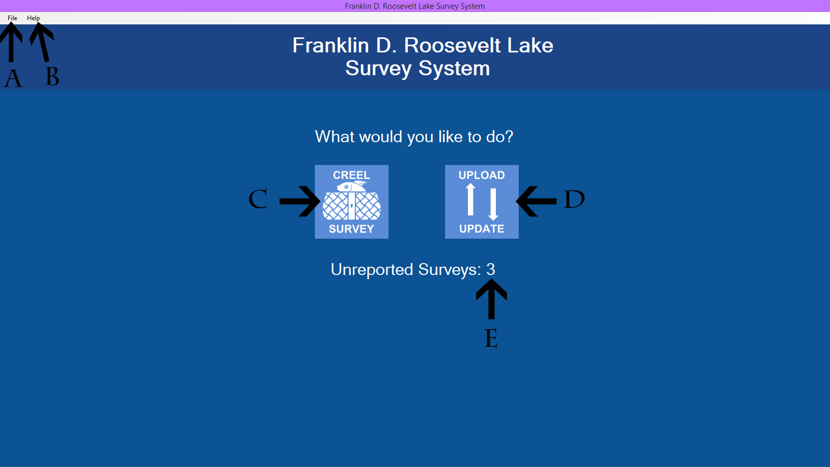

A. Click the File menu and select Exit to exit the application. You must complete a started work day in order to exit the program.

B. Click the Help menu and select the option that you need help with. Help is always accessible.

C. Click the Creel Survey button to begin a creel survey.

D. Click the Upload/Update button to update the codes and upload completed surveys. An internet connection must be present for this operation to complete successfully.

E. This label indicates how many surveys you have to upload to the database.

Help Entering Clerk Information

# Starting the Day

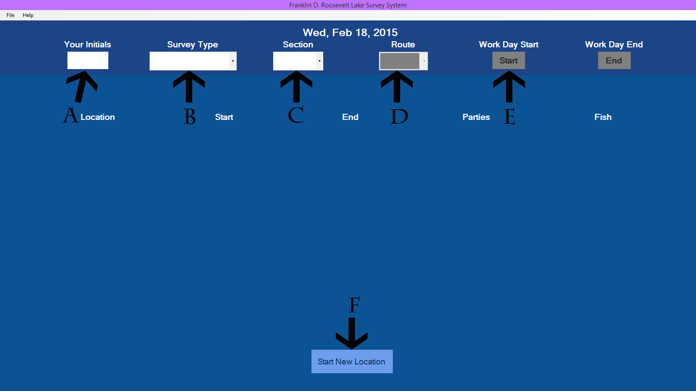

A. Click here to enter your initials.

B. Click here to select the survey type.

C. Click here to select the section.

D. Click here to select the route for the bus-route survey type.

E. Click Start to begin your work day. All fields must be completed, the button will turn green when the fields are completed.

F. Click Start New Location to begin a location. Your work day must be started in order for this button to enable.

# Ending the Day

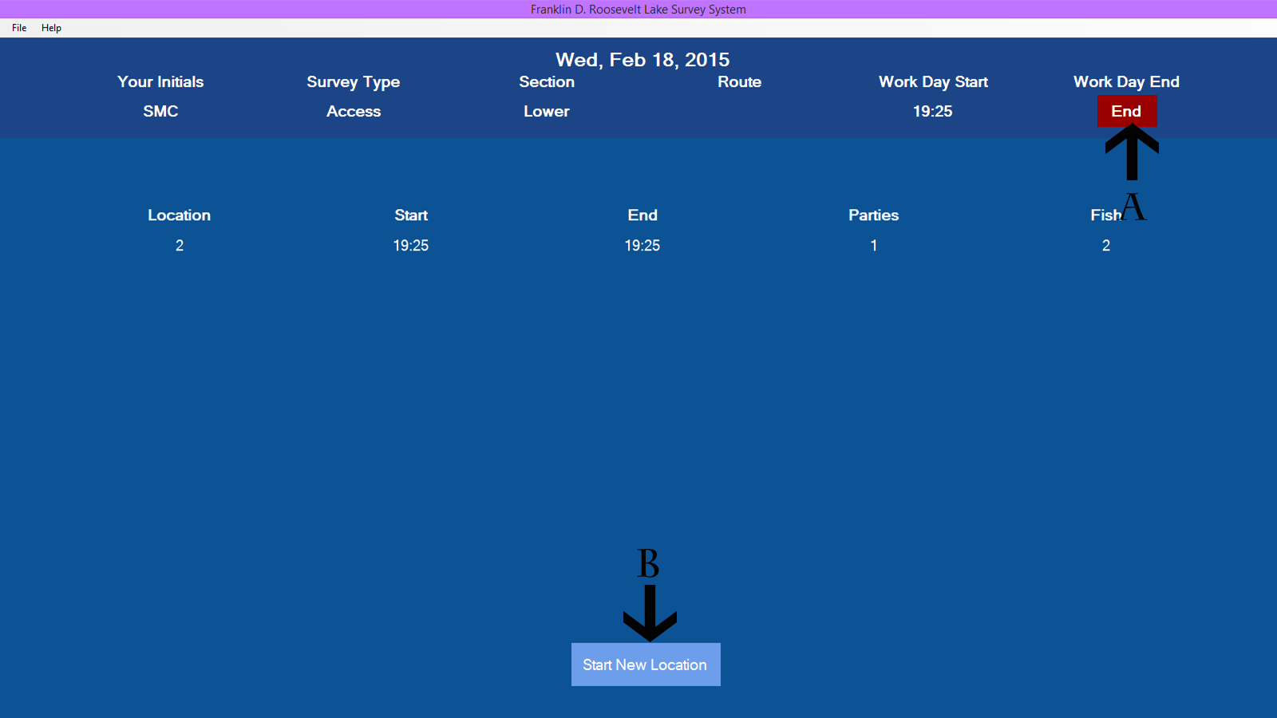

A. Click End to end your work day.

B. After End has been clicked, this button will turn red and say exit. Click this button to return to the welcome screen.

Creel Survey Help

# Selecting a Location

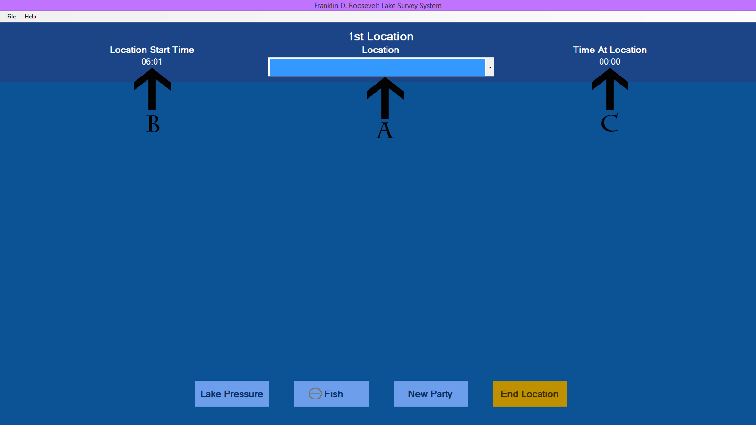

A. Click here to select the location that you are at.

B. Your location start time is automatically entered. You can view it here.

C. Your time at the location is displayed here. You may find this useful when doing the bus-route survey.

# Location Pressure Counts

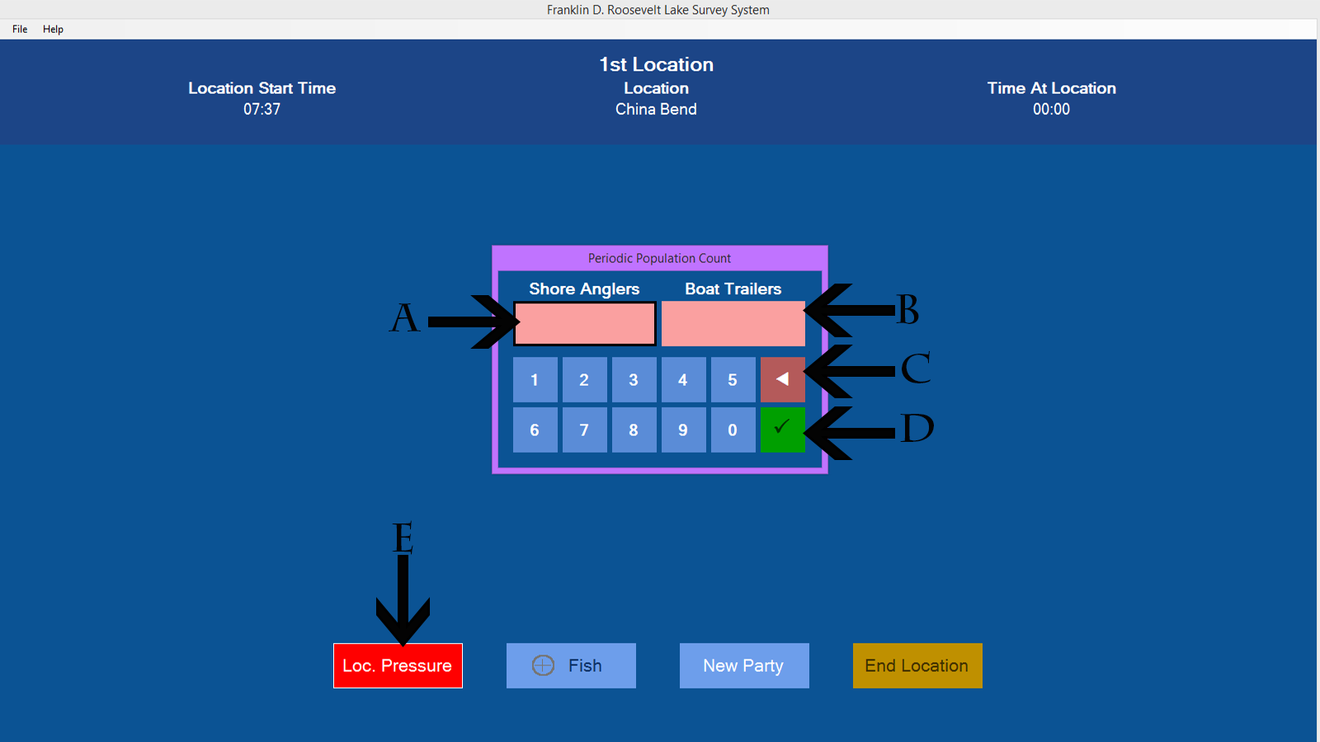

A. Click here to record the shore angler count. You can tell that it is selected by the black border surrounding the box. Click the number keys for the count.

B. Click here to record the boat trailer count. If it is selected there will be a black border surrounding the box. (See A for selected appearance.) Click the number keys for the count.

C. Click here to delete a number.

D. Click here to submit the data. This will only be enabled if both counts are filled in. The check mark will be white when it is enabled.

E. Click the Loc. Pressure button to perform the counts. The button enables every hour and alerts you by turning red. The counts must be performed before leaving a location, so you will also see this box when you click End Location.

# Adding a Party

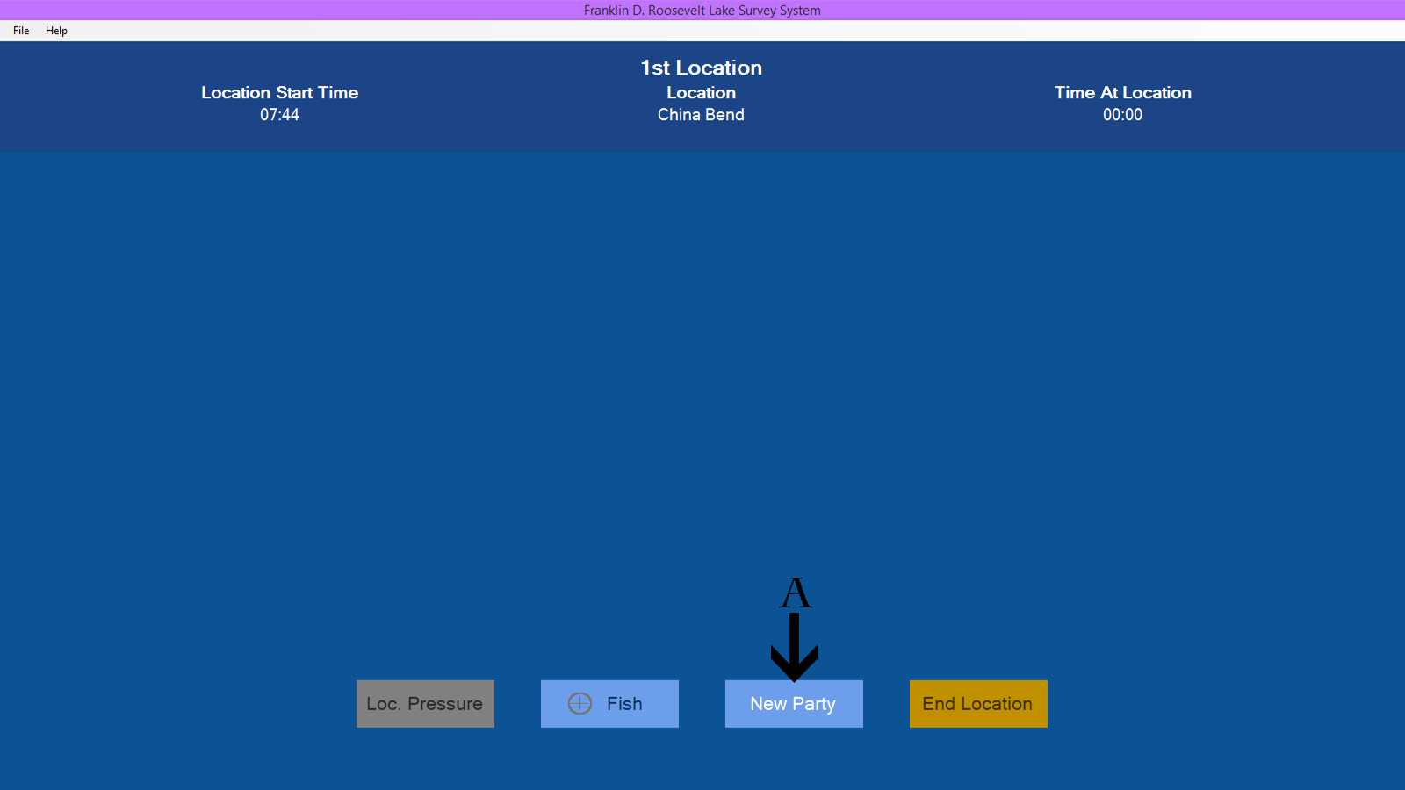

A. Click New Party to add a new party. This button will be enabled whenever a location is selected or a fish is completed.

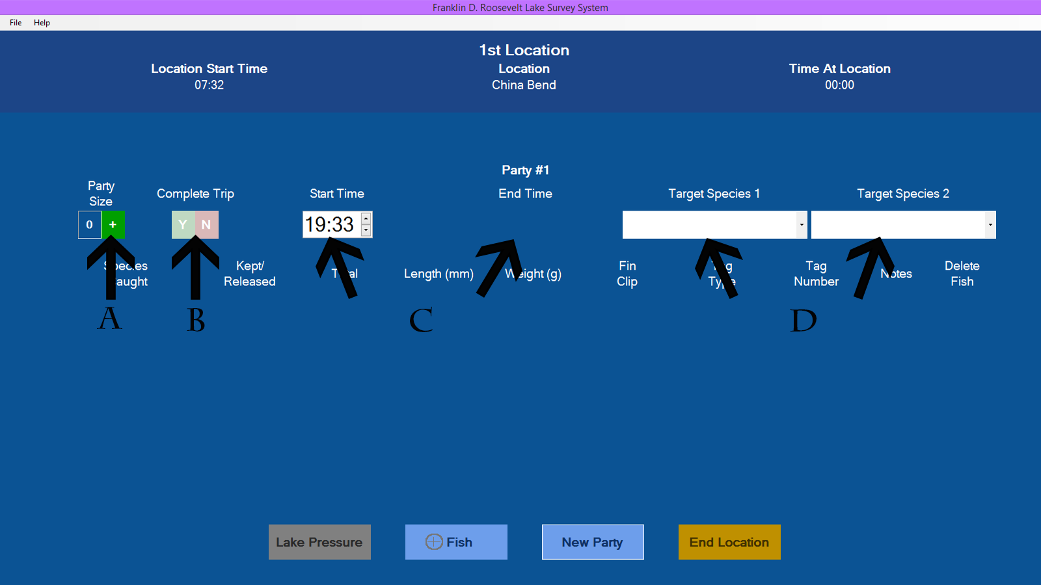

A. Click the + for each angler in the party. See below for help entering angler information.

B. Click the Y for a complete trip. Click the N for an incomplete trip.

C. Click on the hour value to select it. Then click on the up arrow or the down arrow to get to the correct value. Repeat the process for the minute value.

This same process applies to End Time. This control is only present when Y is selected for complete trip.

D. Click here to select the party's target species. This applies to target species 1 and 2.

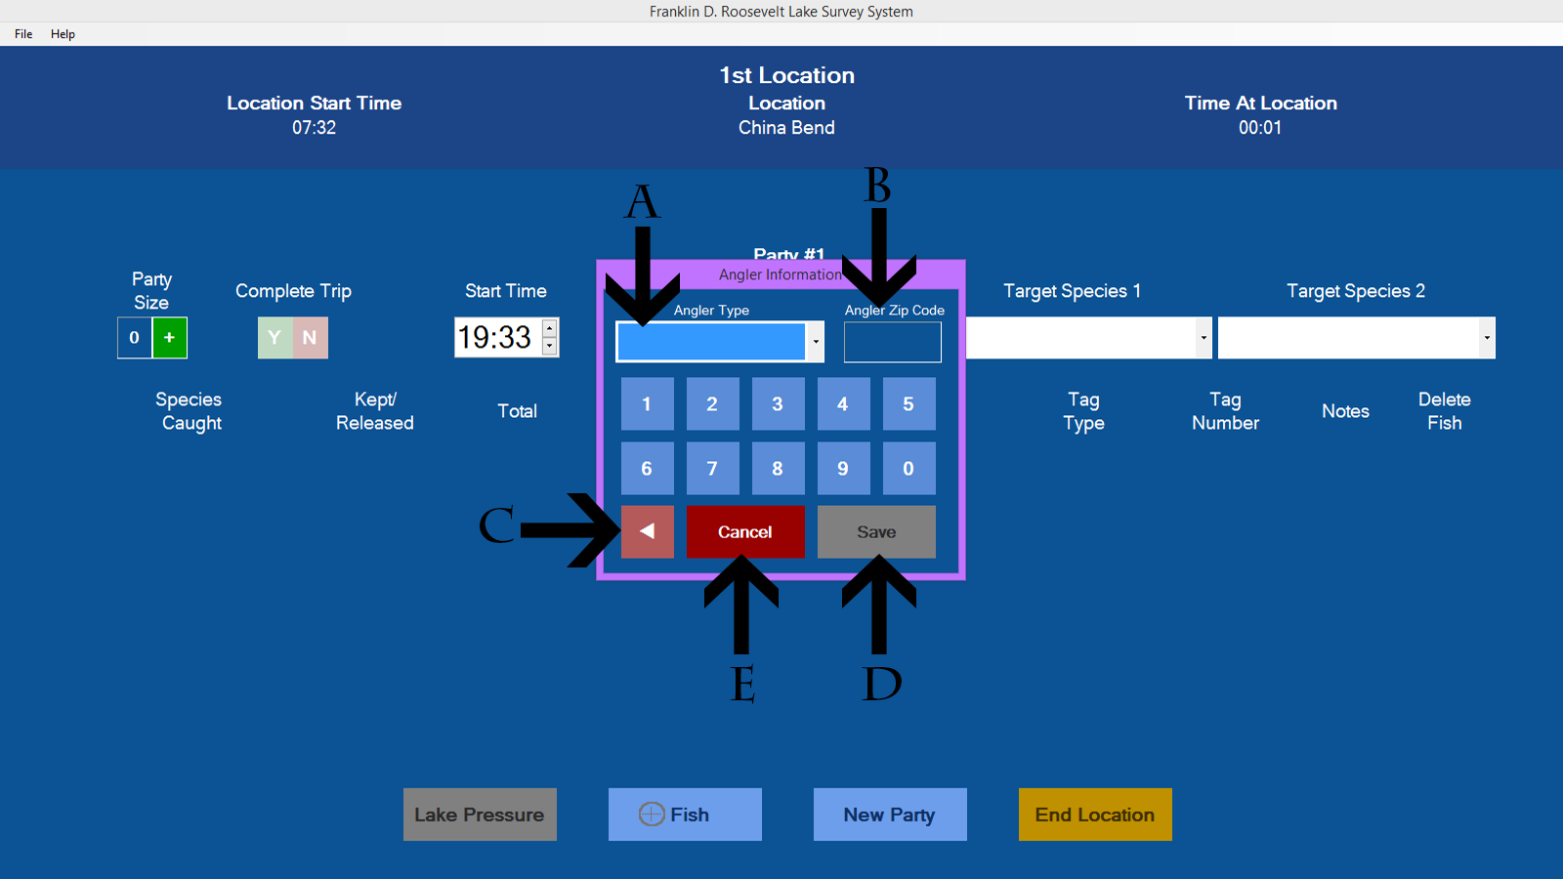

A. Click here to select the angler type.

B. As you click the number keys for the zip code, they will appear here.

C. Click this button to delete numbers from the zip code. See B for the results of this operation.

D. Click Save when you have completed collecting angler information. This button is disabled if the angler type isn't selected or the zip code isn't 5 digits long. The button turns green when enabled.

E. Click Cancel to cancel adding the angler information. Parties must have at least one angler in order to continue.

# Adding a Fish

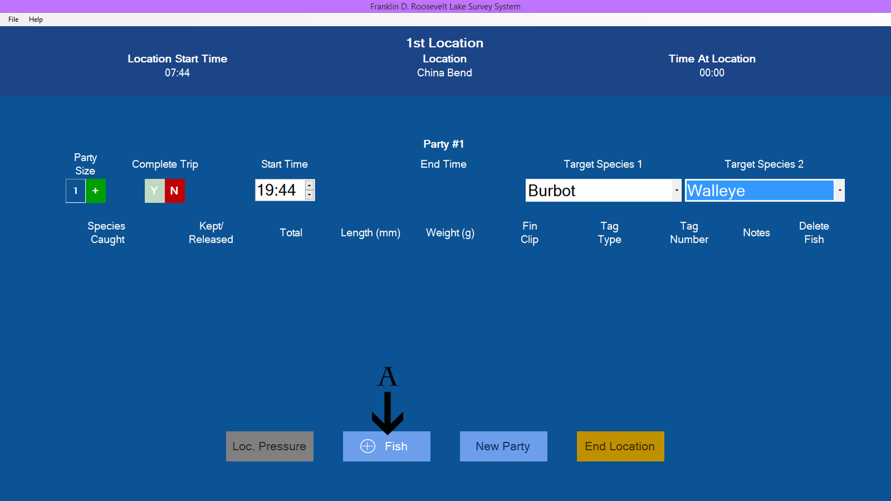

A. Click here to add a fish. This button is enabled whenever party information is completed or a fish is completed. (Continue reading for what makes up a completed fish.)

### 

No Fish Caught

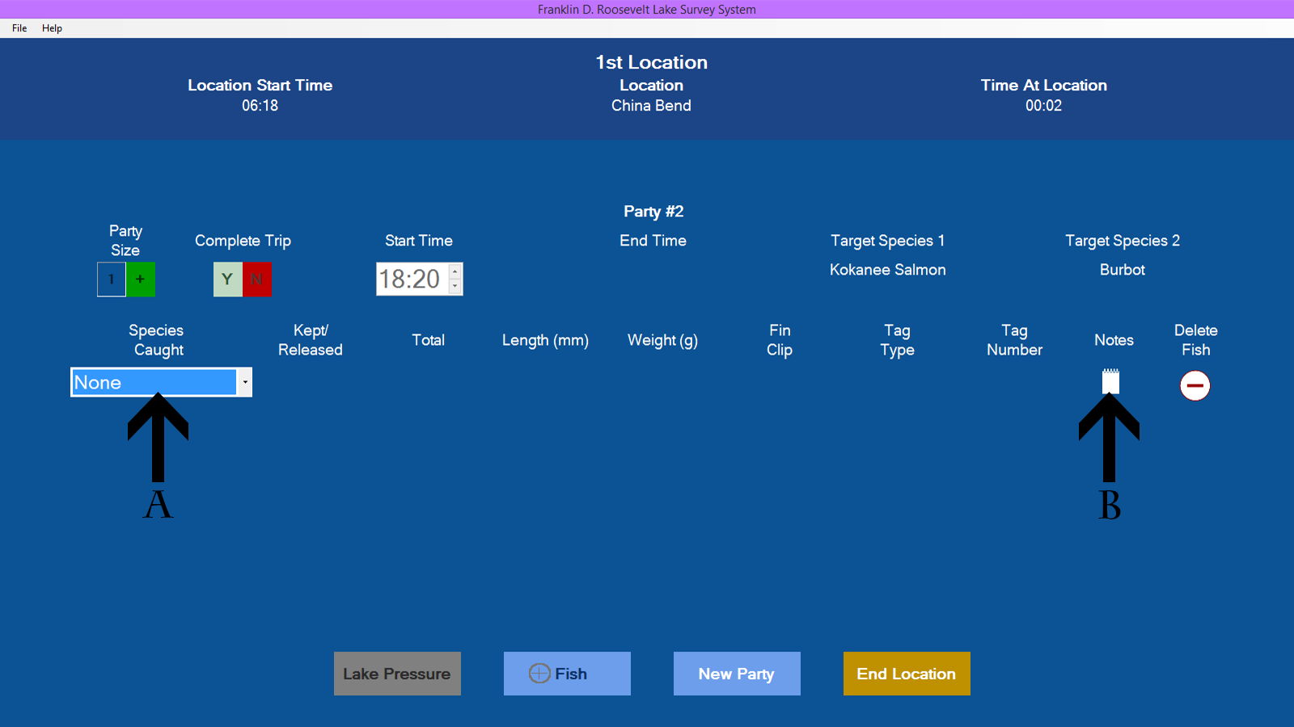

A. Click here and select None from the species list.

B. Click here to add any pertinent notes. (Optional)

Released Fish

**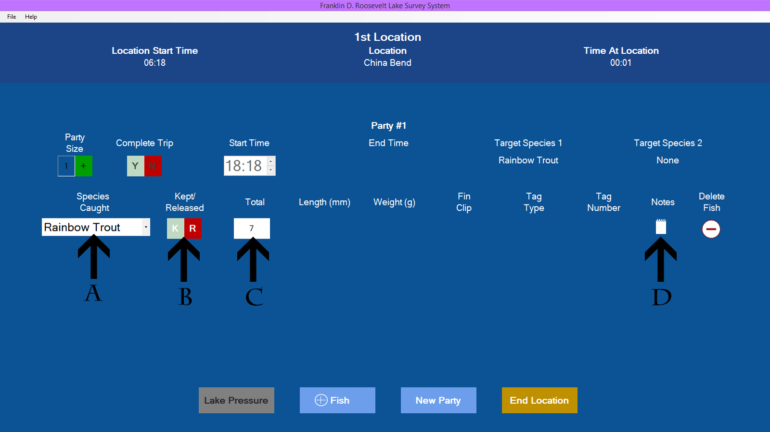**

A. Click here to select the species that was released.

B. Click the R to indicate a released fish.

C. Click here to enter the number of released fish. This value must be greater than 0 and less than 1,000.

D. Click here to add any pertinent notes. (Optional)

Kept Fish

**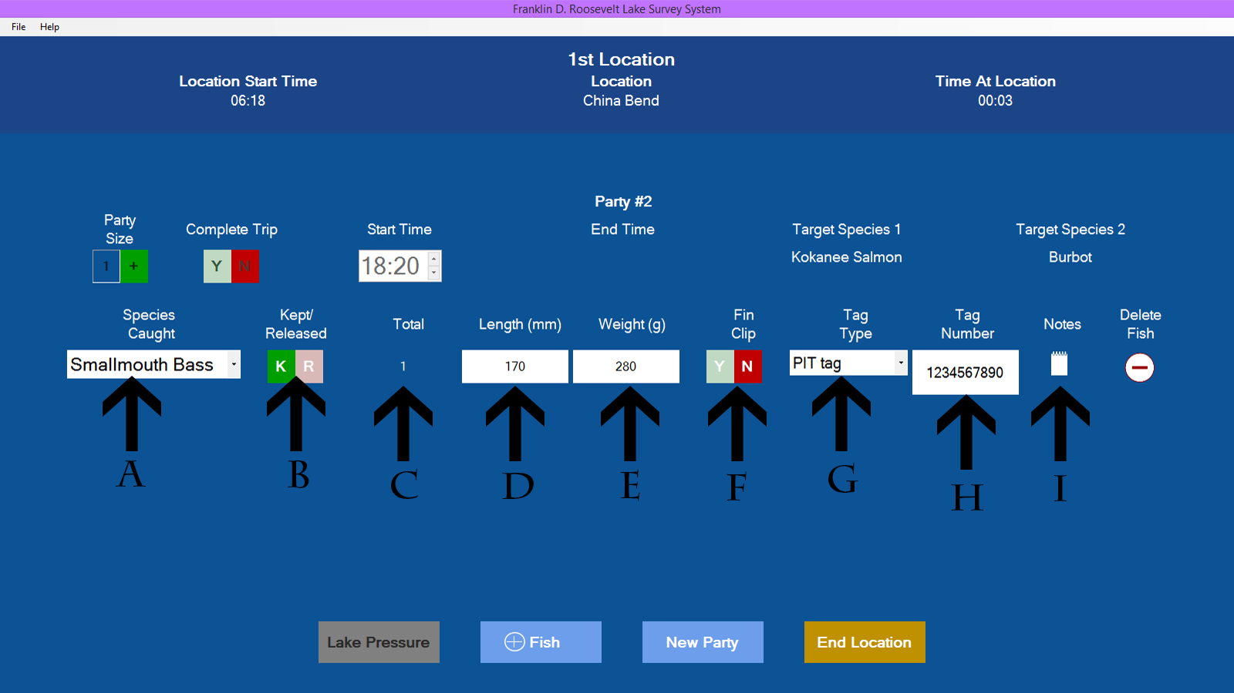**

A. Click here to select the species kept.

B. Click the K to indicate a kept fish.

C. This is a read-only value, you will only be dealing with one fish if it's a kept fish.

D. Click here to enter the length of the fish in millimeters. Enter a value greater than 0 and less than 100,000. This field is optional if you can't measure the fish.

E. Click here to enter the weight of the fish in grams. Enter a value greater than 0 and less than 100,000. This field is optional if you can't weigh the fish.

F. Click Y if the fish has a fin clip. Click N if the fish doesn't have a fin clip. This field is optional if you can't determine this information.

G. Click here to select a tag type. This defaults to none when you add a kept fish. If the tag type is not none, a tag number is required. (See H.)

H. Click here to enter a tag number. If the tag type isn't none, a tag number of 1-20 characters is required.

I. Click here to add any pertinent notes. (Optional)

# Editing/Deleting

Editing a Fish

Any fish in the party can be edited until New Party or End Location is clicked. Simply click on the field that you wish to edit. Remember that all fish must be complete in order to move to the next party or location. (See Adding a Fish for further help.)

Deleting a Fish

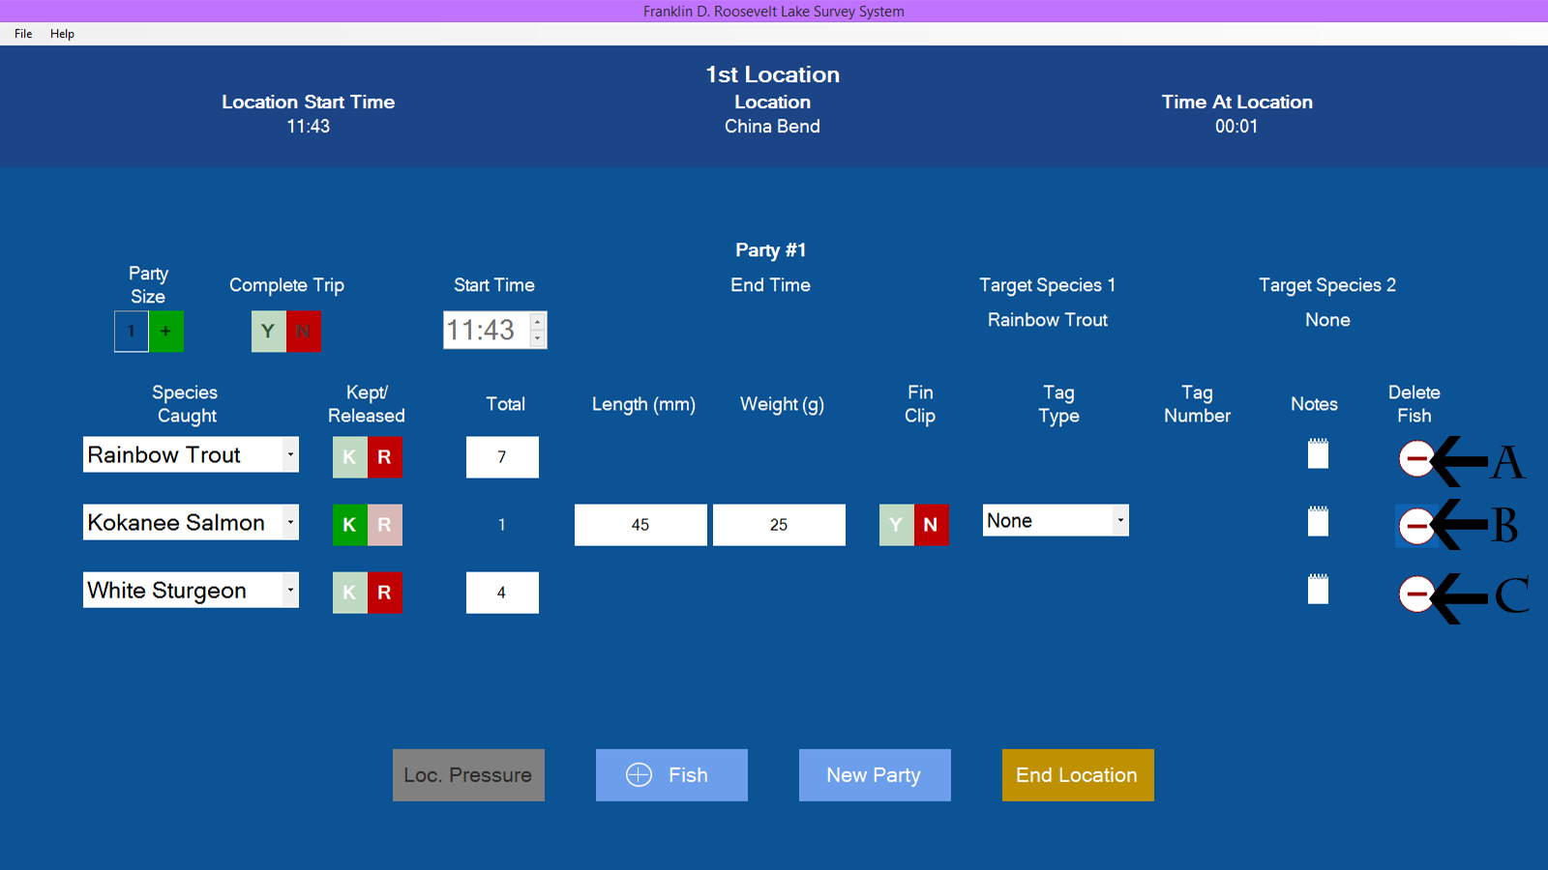

Click on the delete button to delete that fish.

A. Clicking on this button would delete the Rainbow Trout.

B. Clicking on this button would delete the Kokanee Salmon.

C. Clicking on this button would delete the White Sturgeon.

# Ending a Location

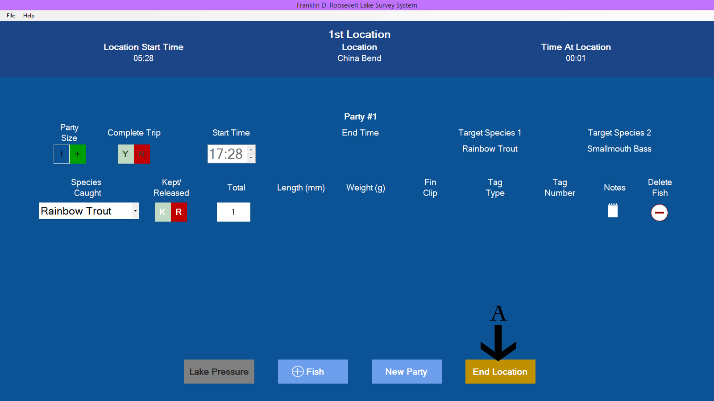

A. Click the End Location button whenever it's enabled to end the location. A location can only be ended if all fish are complete. See Adding a Fish for help completing a fish.

You will be required to do a shore angler and boat trailer count after clicking End Location. See Location Pressure Counts for help completing the counts.

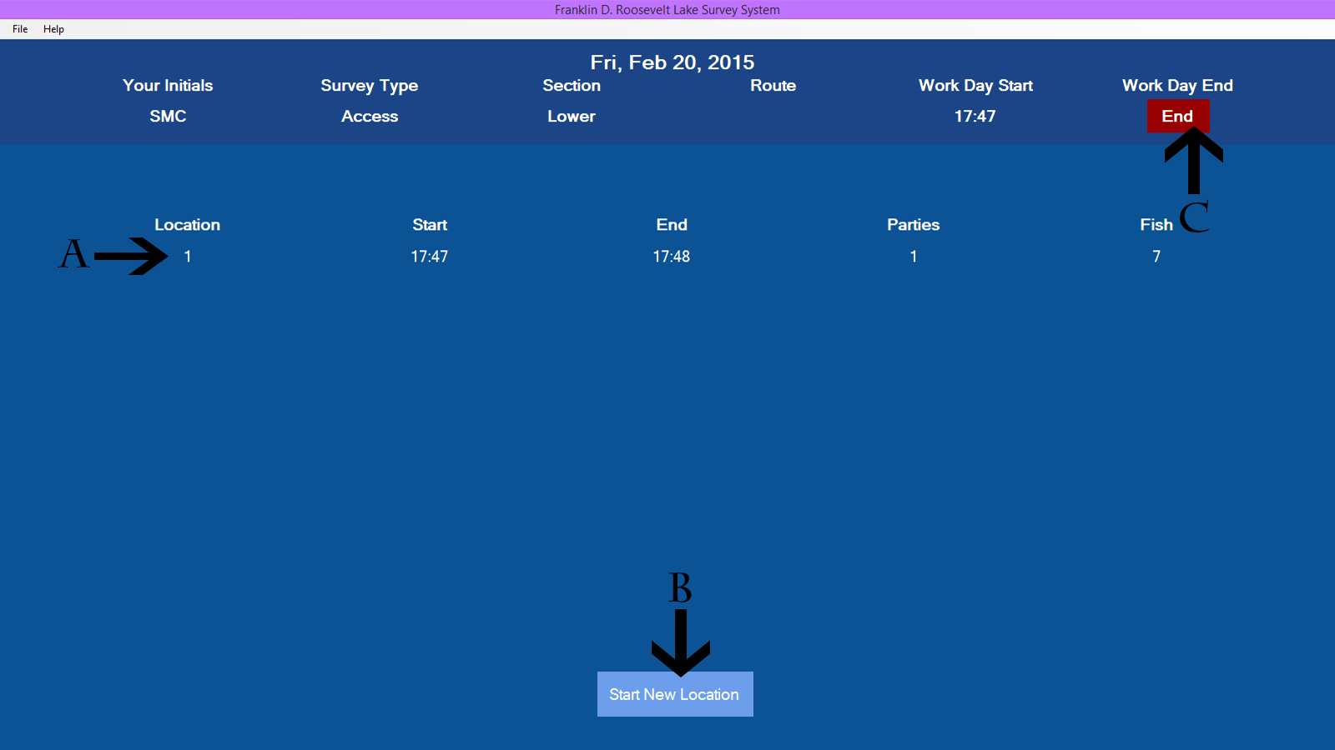

A. After End Location is clicked, the information collected is displayed here.

B. Click Start New Location to start a new location.

C. Click End to end your work day.

See Entering Your Information in the Help menu for further help with B and C.